Overview
Metadata repository (MDR) is a repository within the caB2B local database which stores all the details of the UML model i.e. all CDEs including permissible values, all possible paths(see appendix) between all pairs of classes. This information is retrieved by decomposing the annotated UML model (see appendix) along with details like concept codes and permissible values. MDR also stores all categories (see appendix).
During path generation classes from different applications are connected based on their attribute’s CDE match. It involves matching the concept codes of the classes and their attributes in order. caB2B pre-calculates the paths between all pairs of classes in the UML model and stores them in the Metadata Repository. This facilitates the user to define limits between pair of classes without bothering about the intermediate classes which are part of the path.

Class diagram:

Domain model processing and finding paths:
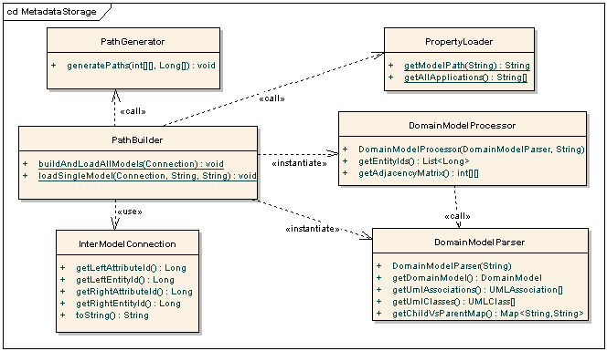
Classes responsible for (1) to (4)

PathBuilder builds all paths for a Domain Model (see appendix) of application. This class acts as a Controller that calls different utility classes to build all possible non-redundant paths for a given model. It also loads the generated paths to database.

DomainModelProcessor stores the UML model to database and generates the information needed for path generating. Using DomainModelParser to get the domain model of application, it generates the adjacency matrix and related information required for path calculation. An instance of this class refers to one domain model

DomainModelParser converts domain model XML file located at given path to caGrid's metadata objects using caGrid's utility.

PathGenerator calculates all possible non redundant paths using the passed adjacency matrix. It writes all paths to file represented by PathConstants.PATH_FILE_NAME

PropertyLoader handles fetching properties from "demo.properties" file. It provides method to get all the applications which are configured in cab2b using "demo.properties". It also gives file system path for the domain model XML of given application.
InterModelConnection represents all the inter model connections present between given pair of entities. Intermodel connection is pair of semantically equivalent (whose CDEs are matched) attributes of classes from different models.

Category operations:
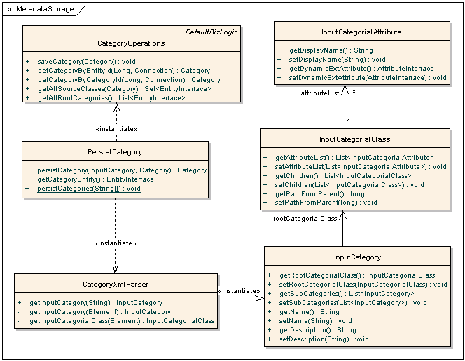
Classes responsible for persisting categories

CategoryXmlParser provides methods to parse Category XML (see appendix) file and convert them to java object form. These java objects will be used in actual category creation and saving.

PersistCategory provides methods to save Category to database. It uses CategoryXmlParser to convert category XML to corresponding objects (Input*) and then builds actual Category objects and saves it to database using Hibernate.

CategoryOperations provides functions for database operations needed for Category like save, retrieve etc.
InputCategory is object representation of "Category" tag.of category XML.
InputCategorialClass is object representation of “CategorialClass" tag of category XML.
InputCategorialAttribute is object representation of "Attribute" tag of category XML.

Sequence diagram – Model and path loading:
Metadata Storage can be divided into following parts
- Get all the application names and file system paths for their domain model XMLs using PropertyLoader
- Convert the XML file to caGRID’s metadata objects using DomainModelParser.
- Use DomainModelProcessor to convert caGRID’s metadata objects to Dynamic Extension’s objects and store them in cab2b metadata repository along with concept code and concept definition.
- Generate paths by traversing the object graph based on the associations and load the the generated paths to database. This is done by PathGenerator
- PathBuilder transfoms the paths from list of entites to list of associations and saves them to database.

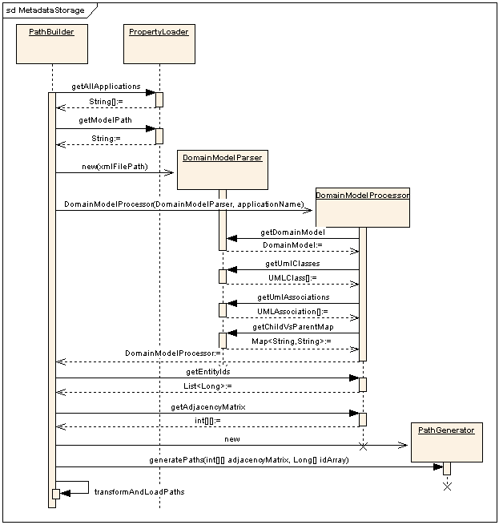

Sequence diagram – Category loading:

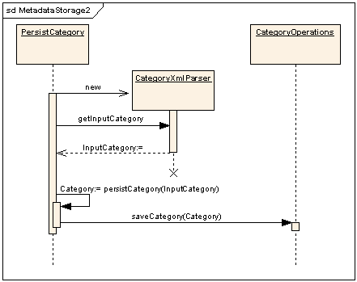

MDR also holds all the Categories. They are defined in a well formed XML file. CategoryXmlParser parses the XML file and converts it to InputCategory object. PersistCategory creates an actual Category object using InputCategory. Then it calls CategoryOperations for saving the category.

Appendix

Category is a logical collection of attributes from different classes, within or across UML models, in such a manner that it makes most sense to the end users.
Annotated UML model or domain model extract is a XML representation of classes used on GRID and defined in UML. These classes and relationships among those objects are formally described, curated, and semantically harmonized. The XML has information about classes, their attributes and permissible values. Classes and attributes have concept codes which are used to determine semantic equvalance between classes and attributes.
Path between a pair of classes is an ordered list of associations between them, in which source of first association if the “from” class and target of the last association is “to” class.
Category XML
It is a well-formed XML file, which defines a category. All categories are first defined as a Category XMl and then they are imported to cab2b MDR. Structure of this file is as follows:
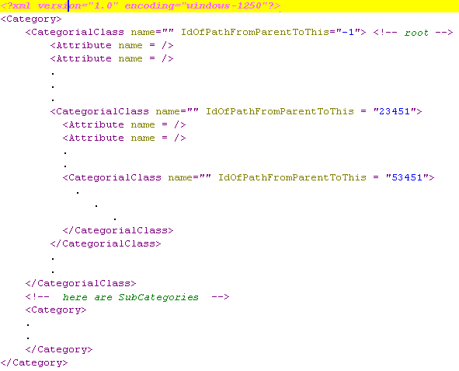

Below is the example of the Category XML file for the category “Genomic identifiers”

